

April 2, 2012

Leaked EU Reports Reveal Outsourcing of Israel Policy to Fringe NGOs

Background

- Since 2010, six documents from the offices of EU representatives in Israel and the Palestinian Authority – dealing with the central, complex, and sensitive issues of Israeli policy in Jerusalem, “Area C,” the status of Israeli-Arab citizens, and the allegations of settler violence – have been leaked to the Israeli and international media. The documents contain similar claims, and repeat allegations and reports from politicized EU-funded non-governmental organizations (NGOs) based in Israel and the Palestinian Authority.
- The EU-NGO collaboration, as expressed in these political documents, is highly problematic: Through Israeli and Palestinian NGOs, funded in non-transparent processes, the EU is attempting to force major changes in Israeli policy by circumventing democratic structures and diplomatic channels, while NGOs are marshalling foreign backing for positions repeatedly rejected by the majority of Israeli citizens.
- The leaked draft documents are:
  - “EU Heads of Mission Report on East Jerusalem” (one from December 2010 / a second from December 2011)
  - “Situation of Arab-Israeli citizens” (December 2011,Confidential Report)
  - “Area C and Palestinian State Building” (July 2011)
  - “Settler Attacks” (internal reports, one from April 2011/ second from February 2012)
- The EU documents contain a series of policy recommendations, justified by one-sided and distorted versions of the facts on the ground. The failure to consult a broader range of sources from a wide spectrum of political positions and to verify NGO factual and legal claims, are major deficiencies.
- The drafts reportedly failed to gain formal EU approval due to objections by officials regarding some of the conclusions and recommendations, but were then leaked.
- The Israeli political advocacy NGOs quoted extensively in these EU papers include ICAHD, HaMoked, ACRI, Ir Amim, Yesh Din, and B’Tselem – all funded through secret processes by the EU and member states. These NGOs consistently present highly partisan versions of the issues, and the EU reports recycle the NGO claims without critical analysis.
- These leaked publications reflect positions that are inconsistent with a peace process based on mutual understanding and acceptance, and reflect the damage resulting from the close and secretive funding relationship between the EU and the political advocacy NGOs that they fund.
- The repeated unauthorized release of EU draft documents seeking to force changes in Israeli policy, and based on false or unverifiable claims from political NGOs funded by the EU, violates the basic tenets of due process, diplomacy, and responsible government.

Analysis

Jerusalem Documents
Both the 2010 and 2011 EU reports on Jerusalem lack substantive references or footnotes. However, it is evident from the data presented, the rhetoric used, and the specific topics discussed that both reports are based mainly on highly politicized NGO publications.

For instance, the section titled “Planning Demolition, Evictions and Displacement” in the 2011 report appears to be based almost entirely on an ICAHD document “No Home No Homeland: A New Normative Framework for Examining the Practice of Administrative Home Demolitions in East Jerusalem” (October 31, 2011). ICAHD is a fringe political NGO that accuses Israel of “apartheid,” “war crimes,” and “ethnic cleansing” in Jerusalem. Similarly, the “Archeology” section appears to be based on the agenda and claims of the Israeli NGO, Emek Shaveh; the “Education” section is based on a joint ACRI-Ir Amim report. Other sections appear to be based on OCHA and U.S. State Department reports, which also rely extensively on NGO narratives.

In accordance with the biases and distortions of these NGOs, the leaked EU 2011 Jerusalem report claims to document “deterioration on the ground” and repeats unsubstantiated allegations of “unjustified” house demolitions and discrimination in health and education.

The draft EU reports and accompanying policy recommendations also omit key evidence that is inconsistent with the NGOs’ agendas. For example, in 2011 the Jerusalem municipality provided building permits for Arab residents of Jerusalem at a level comparable to Jewish residents; built post offices, public clinics, and classrooms; inaugurated the light rail, which serves both Arab and Jewish neighborhoods; and started to implement other programs for the benefit of Arab neighborhoods. Moreover, it does not appear that the EU consulted with the Israeli government or officials from the Jerusalem municipality to verify the NGO claims in drafting this report.

Examples of quotes from NGO reports on Jerusalem echoed in EU leaks

EU Report | NGO Report
“The Planning regime poses a difficult dilemma for Palestinian families: they have the choice between migrating outside the municipal area of Jerusalem or building without the necessary building permit.” (EHoM Jerusalem report 2011 article 28) | “[T]he obstacles placed before Palestinians wishing to obtain building permits, produces a situation in which many Palestinians are faced with the harsh choice between leaving their East Jerusalem homes or building without authorization…” (ICAHD “No Home No Homeland” p.32)
“Planning for, and the construction of, an additional 352 classrooms has begun. However, as approximately 1,500 additional classrooms are needed as of today, a significant gap will remain. The demand for classrooms is likely to grow even further as the Palestinian population increases.” (EHoM Jerusalem report 2011 article 44) | “193 classrooms are in planning procedures; and another 96 classrooms are in initial procedures. The total is 352 more classrooms…but even when construction of all the planned classrooms is completed, there will still remain a substantial gap between the needs of the growing population and the existing number of classrooms” (ACRI/Ir Amim  “The East Jerusalem School System – Annual Status Report September 2011” p.6)
“Though East Jerusalemites are included in and contribute to the Israeli health system their access to health care is also restricted by the security requirement for Israeli ambulance staff to enter Palestinian neighbourhoods in East Jerusalem only under police escort. Requests for the dispatch of ambulances regularly result in unnecessary, and potentially life-threatening, delays for Palestinian residents in East Jerusalem.” (EHoM Jerusalem report 2010 article 44) | “Magen David Adom (MDA) ambulances may not enter Palestinian neighborhoods in East Jerusalem to transfer injured or sick persons to hospital without a police escort, even in life threatening situations Preventing ambulances from entering Palestinian neighborhoods in East Jerusalem without a police escort violates the residents’ right to life and health… This delay sometimes leads to a significant deterioration in the patient's condition or even death.” (Adalah/PHR-I/Al-Mezan “Ambulances Prevented from Entering Palestinian Neighborhoods in East Jerusalem without Prior Approval or Police Escort” November 2009)
“The economic situation in East Jerusalem remains a major source of concern. The barrier continues to have a particularly adverse impact on the traditionally strong trade links between the West Bank and East Jerusalem”. (EHoM Jerusalem report 2010 article 45) | “The separation fence has contributed to the continued economic deterioration of East Jerusalem and the rise in the poverty level. In the past, East Jerusalem flourished as the economic center of the West Bank. With the institution of the fence system and its attending permits, East Jerusalem was almost completely disconnected from the West Bank.” (Ir Amim, Separation Barrier)
In East Jerusalem 35 percent of the land has been expropriated as “state land”. Only citizens of Israel or those .legally entitled to claim Israeli citizenship (i.e. Jewish) can buy property built on state land. (EoHM Jerusalem report 2010 article 7) | Under Israeli law, to qualify to purchase property that is “state land” the purchaser must either be a citizen of Israel (Palestinian Jerusalemites are legal residents of the city, not citizens of Israel) or legally entitled to citizenship under the law of return (i.e. Jewish)...Not only are Palestinian Jerusalemites barred from purchasing property in most of West Jerusalem, but they are also barred from purchasing property in the 35% of East Jerusalem that Israel has expropriated as "State Land" since 1967, and on which Israel's East Jerusalem settlements have been built. (Lara Friedman, Americans for Peace Now and Daniel Seidemann, Terrestrial Jerusalem, “Settlements in Focus: Top 6 Bogus Excuses for East Jerusalem Settlement Expansion” March 25, 2010)

In addition to these quotes, which reflect the extent to which the EU Jerusalem reports are based on NGO claims, the documents patronizingly absolve the Palestinians of responsibility for the issues raised. Furthermore, the complex security context of Israeli actions since the beginning of the Palestinian terror campaign in 2000 (the “Second Intifada”), and the historical background are often ignored, resulting in a highly distorted narrative.

- As an illustration of this systematic distortion, both EU reports on Jerusalem appear to rely on a joint Adalah, Al-Mezan and PHR-I press release claiming that a “requirement for Israeli ambulance staff to enter Palestinian neighborhoods in East Jerusalem only under police escort” regularly results in “unnecessary, and potentially life-threatening, delays for Palestinian residents in East Jerusalem.” The NGOs and the EU fail to mention the numerous incidents of Israeli ambulances being attacked while responding to emergency calls in those neighborhoods, thus creating a perception that Israel needlessly discriminates against Palestinians, and denies them medical attention.
- Both EU documents claim that “The institutional and leadership vacuum in East Jerusalem created by the prolonged closure of those institutions, in particular that of the Orient House.” They erase the background to the Orient House closure in August 2001, when, as part of Israel’s defense against mass terror, including in the center of Jerusalem, Israeli security forces found stolen weapons in the Orient House and documents proving that Palestinian officials had been operating illegally from this building.
- The Temple Mount and access to this sacred area are among the most sensitive and complex issues in the conflict. In these reports, the controversy related to repairs to the Mughrabi Bridge (the main access point for Jews and other non-Moslems) is presented in a highly misleading and partisan manner, echoing the unfounded allegations by the Waqf and other Muslim groups that Israel is undermining the Al-Aqsa Mosque. In parallel, the Waqf’s consistent and clearly documented violations in the area are ignored. These false allegations are routinely used by Muslim leaders as a pretext for incitement to violence against Israel. Additionally, according to Israel State Comptroller report published in May 2011, the Waqf caused severe damage to the Temple Mount by illegally digging below it. The leaked EU publications and their original NGO reports largely ignore these basic dimensions.
- Adopting the distortions of politicized NGOs, possibly Americans for Peace Now and Terrestrial Jerusalem (founded by Danny Seidemann, a former Ir Amim official), the 2010 EU report also grossly misrepresents Israeli law. The EU claims that “Only citizens of Israel or those legally entitled to claim Israeli citizenship (i.e. Jewish) can buy property built on state land,” implying state racism. In reality, Israeli law and court rulings bar racial or other discrimination in the disposition of state land, including sales. Additionally, Israeli law explicitly allows for every citizen or permanent resident to buy property built on state land, regardless of religion, race, or nationality, it also explicitly permits officials to certify sales to non-citizen non-residents.
- The reports also fail to mention that Arab residents of Jerusalem are entitled to Israeli citizenship, thus enabling them to retain their legal status and its accompanying benefits even if they leave the city. However, exercise of this right is usually rejected for political reasons. This omitted fact contradicts the justification provided by political NGOs and the EU for illegal building activities, based on the “need” to circumvent Jerusalem’s legal procedures and processes to obtain construction permits in order to avoid “the risk of residency revocation.”

The EU and the Arab Citizens of Israel
On December 16, 2011, several media platforms published excerpts from a “classified EU document” discussing another very complex and sensitive internal Israeli issue - the status of the Arab-Israeli citizens. Unlike the Jerusalem reports discussed in this report, the full text of the Arab-Israeli report is not publically available.

The selective press accounts cited recommendations that the EU treat this as a “core issue, not second tier to the Israeli-Palestinian conflict.” One media report asserts that the document is designated “food for thought,” as opposed to a policy “report.”

According to Ha’aretz and The Independent, the document discusses “The stalemate in the peace process, and the continuing occupation, [that] inevitably has an impact on the identification of Israeli Arabs with Israel.” Ha’aretz reported that an earlier draft “also included suggestions for action the EU should take, but these were removed from the final version at the insistence of several countries.”

A press release by the Israeli political advocacy NGO Adalah (December 22, 2011; original in Arabic) claimed that the leaked EU document “adopts many of the recommendations contained in the report on ‘European Union and the Palestinian minority in Israel,’ issued by Adalah and the Arab Association for Human Rights Network Euro-Mediterranean Human Rights Network (EMHRN) in February 2011.” (Both groups are funded directly by the EU.) This was not the first time that the EU copied Adalah’s talking points. In February 2011, following the publication of Adalah’s report and “increased advocacy efforts before the EU”, the EU released a statement “that called upon Israel to protect the rights of Arab citizens of Israel.”

Additionally, two weeks before the leak (November 30), Adalah presented to the EU a “briefing paper” titled “Major developments regarding the rights of Palestinian Arab citizens of Israel in 2011.” The report discusses Knesset proposals, the Bedouin in the Negev, alleged “discriminating government policy towards Arab citizens,” and the claimed “attack on human rights organizations and activists” – the same subjects reportedly addressed in the EU report.

This process and the EU document illustrate the closed echo chamber created by the EU and the selected NGOs that receive funding, which excludes debate and ensures that the EU will extend funds for future NGO projects.

West Bank violence
On March 14, 2012, the EU Observer reported that EU officials in Ramallah had published “an internal three-page report dated February 2012” claiming that “Israeli authorities are not doing enough to stop a massive increase in attacks by Jewish extremists against Palestinians.”

The EU Observer also reported that EU officials “depicted settler attacks as part of a broader Israeli campaign to get rid of the Palestinians,” and that “an earlier eight-page EU report on the subject dated April 2011 - also seen by this website - said Israel has created an ‘atmosphere of impunity’ for Jewish attackers, amounting to ‘tacit approval by the state.’”

The statistics quoted in the article suggest that these leaked EU reports are also based on NGO publications. For instance, the 2012 report allegedly claims that “over 90 percent of complaints filed by Palestinians ended with no indictment.” This parallels a Yesh Din publication “Law Enforcement upon Israeli Civilians in the West Bank” (February 16, 2011), alleging that “[t]he clear majority of investigations [into complaints by Palestinians] – more than 90 percent – are closed on grounds that suggest that the investigation has failed.”

The Yesh Din allegations are highly misleading and unverifiable, as documented in a detailed analysis. For instance, Yesh Din fails to provide comparative data that would indicate whether its claims regarding the West Bank are anomalous or typical for police investigations. Furthermore, echoing Yesh Din’s political agenda, the EU appears to be unaware of the Israeli government’s response, failing to mention the widespread condemnation of this violence and the establishment of a special police task force to address this issue.

“Area C” –EU Triple-Recycling From UNOCHA/NGO Political Publications
Similar to the other unauthorized EU publications, the leaked report on Area C (“Area C and Palestinian State Building”) also uses NGO data and claims as the basis for policy recommendations that seek to forcibly alter Israeli government policies. More than half of the references cite NGO publications, both directly, and indirectly via UNOCHA, as well as their incorrect or unverifiable claims.

A clear example of data recycling, without verification, is the reference to Save the Children UK for the claim that “[p]rior to the Israeli occupation in 1967, Palestinian population of the Jordan Valley was estimated at between 200,000 and 320,000. As of 2009 the population is approximately 56,000...” This is used as evidence that “the Palestinian presence in Area C has continuously been undermined...by Israel as occupying power.” These figures actually originated with the Palestinian NGO Ma’an Development Center, whose “data” change from report to report, and Ma’an cites no external sources. Moreover, these figures appear to be greatly inflated: according to Israel’s 1967 West Bank census, the entire population of the West Bank was only 598,637, with 9,078 in the Jericho district (the only city in the Jordan Valley).

In addition to NGO publications, the UN Office for the Coordination of Humanitarian Affairs (OCHA) is cited with similar frequency. However, NGOs are also often the original sources for OCHA reports.

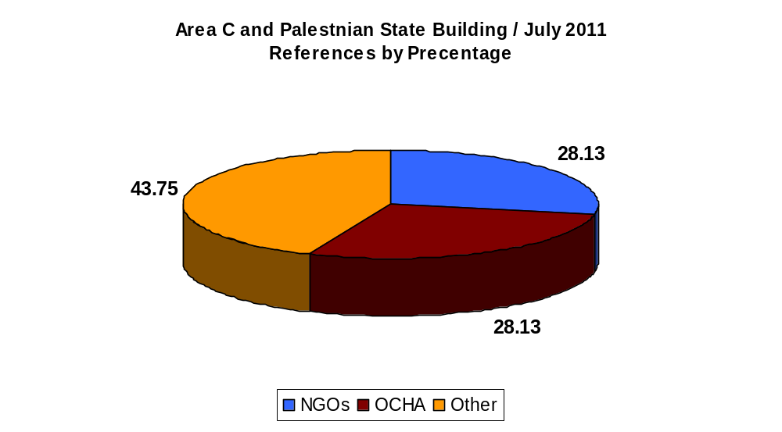
As shown in the graph below, one-third of the EU’s Area C document’s references stem from four OCHA reports: Restricting Space: The Planning Regime Applied by Israel in Area C of the West Bank (December 2009); West Bank Movement and Access (June 2010); Area C Humanitarian Response Plan Fact Sheet (August 2010); and The Monthly Humanitarian Monitor (January 2011).

OCHA reports are largely based on NGOs publications, as well on other OCHA reports, creating a closed circle of citations and references. For example, the references in “Restricting Space” include 22 references (45%) to three NGOs, 19 of them quoting the same report authored by Israeli political advocacy NGO Bimkom.

References' Distribution in OCHA Reports
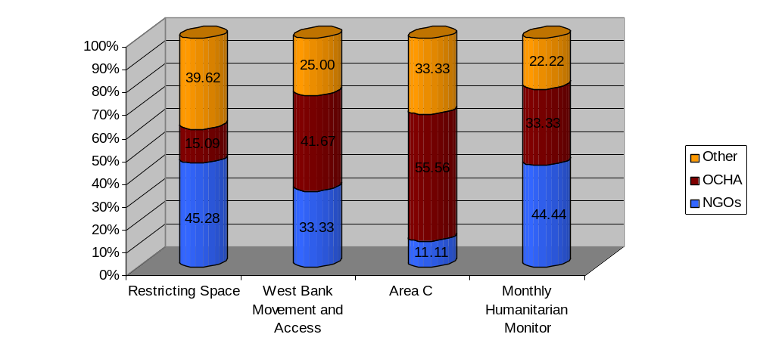

Appendix 1 / Secrecy in European government funding
for political advocacy NGOs

Over the past five years, NGO Monitor has documented the systematic absence of transparency and accountability in EU and European government funding for non-governmental organizations (NGOs) that selectively target Israeli policies. The European Commission and most European governments release little or no significant information on these funding processes, by which an estimated €50 million that originate with European taxpayers are transferred annually to highly problematic political advocacy NGOs. (These political activities have been documented in detailed by NGO Monitor.)

For all parties impacted b this European public funding involving tens of millions of euros, information on the individuals making these decisions (to ensure against conflicts of interest), the nature of the evaluations, and other key aspects are necessary.

Therefore, beginning in 2008, NGO Monitor filed Freedom of Information requests with the European Commission seeking documents related to the NGO funding processes and structures, but all such requests were denied under a variety of rationales. In January 2010, NGO Monitor filed a lawsuit against the European Commission in the European Count of Justice. However, in two years, not a single hearing has been held, further highlighting the intensity with which the EU seeks to prevent any funding public disclosure or discussion regarding funding for political advocacy NGOs.

As a result of this secrecy, which has enveloped NGO funding provided by European governments in violation of democratic transparency norms, has also led to a number of Israeli legislative initiatives. Instead of adjusting policies to increase transparency and accountability, Israeli NGOs and their European backers attack the proposals as “anti-democratic.”

The following detailed analysis of differing forms of European secrecy regarding funding for these NGOs provides a background to this controversy.

Appendix 2 / Government funders of NGOs utilized in EU reports

NGO | Direct government funding | Indirect government funding | Total government donations (in NIS) | Percentage of total donations
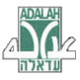  Adalah | EU; Switzerland; joint funds from Denmark, Sweden, Netherlands, Switzerland | Netherlands (via Oxfam Novib) | Non-transparent*
Association for Civil Rights in Israel (ACRI) | Germany; Spain; EU; Norway; UK; Netherlands; joint funds from Denmark, Sweden, Netherlands, Switzerland | Sweden (via Diakonia); Netherlands (via Kerk in Actie) | 1,480,469 (in 2009) | 53%
Alternative Information Center (AIC) |  | Sweden (via Diakonia); Netherlands (via ICCO); UK (via Christian Aid); Catalan (via Sodepau); Spanish (via Mundubat); Belgium (via Solidarite Socialiste) | 1,701,935 (2009) | 76.8%
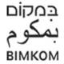Bimkom | UK; Spain; Ireland; EU; joint funds from Denmark, Sweden, Netherlands, Switzerland | Netherlands (via Oxfam Novib) | 1,305,675 (2009) | 44.3%
B’Tselem | Switzerland; Denmark; EU; Netherlands; Norway; Spain; UK; joint funds from Denmark, Sweden, Netherlands, Switzerland | Netherlands (via ICCO; Oxfam Novib); Sweden (via Diakonia); Denmark (via Dan Church Aid); Ireland (via Tocaire); UK (via Christian Aid); Germany (via EED) | 5,388,869 (2009) | 62%
Emek Shaveh | Norway; EU (via Anna Lindh Foundation) |  | 222,949 (2010 - Norway) | 64%
HaMoked | Canada; Spain; EU; Finland; France; Norway; Netherlands; joint funds from Denmark, Sweden, Netherlands, Switzerland | Germany (via E.E.D.); Netherlands (via Oxfam Novib); Sweden (via Diakonia); Ireland (via Trocaire) | 4,359,792 (2009) | 65%
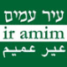Ir Amim | EU; Norway; Sweden; UK; joint funds from Denmark, Sweden, Netherlands, Switzerland | Netherlands (via Oxfam Novib) | 2,771,001 (2009) | 73.9%
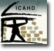Israeli Committee Against House Demolitions (ICAHD) | Spain; EU; joint funds from Denmark, Sweden, Netherlands, Switzerland |  | Non-transparent**
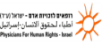Physicians for Human Rights- Israel (PHR-I) | Spain; France; Netherlands; EU; Japan; joint funds from Denmark, Sweden, Netherlands, Switzerland | Sweden (via Diakonia); UK (via Christian Aid); Germany (via EED; Medico International); Switzerland (via Medico Schweiz) | 2,590,000 (2010) | 53%
Yesh Din | Belgium; EU; Norway; Netherlands; Ireland; UK; Germany; joint funds | Netherlands (via Oxfam Novib) | 3,132,088 (2009) | 72%

* Last financial report to Israeli Registrar of Non-Profits was in 2008.
** Last financial report to Israeli Registrar of Non-Profits was in 2007.

Appendix 3 / NGO Reports used in the Jerusalem 2010 Report

Para. | Subject | NGO | Source | Page
7 | Settlements | Ir Amim | Shady Dealings in Silwan | 9-10
7 | Settlements | Peace Now | East Jerusalem
12 | Historic Basin | ACRI | Unsafe Place | 27,36
14 | Historic Basin | Ir Amim | ISRAELI SETTLEMENT IN PALESTINIAN COMMUNITIES IN EAST JERUSALEM
17 | Inner Ring | Ir Amim | No Link
21 | Archeology | Ir Amim | Excavations and National Parks as Political Instruments
23 | Planning, Demolitions and Evictions | ICAHD | East Jerusalem Demolitions
30 | Residency Status | Ir Amim | The Legal Status of the Palestinian Residents in East Jerusalem
34, 35 | Access and Movement | Ir Amim | Considerations in Drawing the Route
34, 35 | Access and Movement | Betselem | The Separation Barrier
36 | Access and Movement | Ir Amim | The Wall in Walajeh
38 | Education | Ir Amim | Socioeconomic Effects
38 | Education | Betselem | Separation Barrier
39 | Education | Ir Amim | Failed Grade | 9
39 | Education | ACRI | The Arab-Palestinian School System in East Jerusalem | 4
44 | Health | Adalah | Ambulances Prevented from Entering Palestinian Neighborhoods in East Jerusalem without Prior Approval or Police Escort
44 | Health | Al Mian
44 | Health | PHR-I
45 | Economy | Ir Amim | Socioeconomic Effects
46 | Economy | ICAHD | The gap distribution of the municipality's budget for 2003 Between East and West City | 12-13
46 | Economy | Ir Amim | About municipal inequality

Appendix 4 / NGO Reports used in the Jerusalem 2011 Report

Para. | Subject | NGO | Source | Page
24,25 | Archeology | Emek Shave | Between Holiness and Propaganda | 17,23
24,25 | Archeology | Emek Shave | Elad's Settlement in Silwan
26 | Planning, Demolitions, Evictions and Displacment | ICAHD | No home no homeland | 15,19
27 | Planning, Demolitions, Evictions and Displacment | Ir Amim | A layman’s guide to home demolitions
28,30 | Planning, Demolitions, Evictions and Displacment | ICAHD | No home no homeland | 32
31 | Planning, Demolitions, Evictions and Displacment | Betselem | 10 Oct. '11: Civil Administration plans to expel tens of thousands of Bedouins from Area C
37 | Access and Movement | ICAHD | No home no homeland | 31
40 | Access and Movement | +972 (AIC) | Checkpoint at J’lem refugee camp form of “ethnic cleansing”
43-45,47 | Education | ACRI | The East Jerusalem School System – Annual Status Report September 2011 | 2,8,10
43-45,47 | Education | Ir Amim |  | 2,8,10
53 | Health | Adalah | Ambulances Prevented from Entering Palestinian Neighborhoods in East Jerusalem without Prior Approval or Police Escort
53 | Health | Al Mizan
53 | Health | PHR-I
56 | Economy, Transport and Infrastracture | ICAHD | No home no homeland | 21

Appendix 5 / NGO Reports as quoted in Area C

Para. | Subject | NGO | Source
4 | The Palestinian Authority | Miftah | Ending the Occupation
5 | Population and Demographic | Save The Children UK | Jordan Valley Fact Sheet
9 | Israeli Settlements | Betselem | Access Denied
9 | Israeli Settlements | Badil | Badil’s Written Report in Response to Israel’s Third Periodic Report to the UN Human
9 | Israeli Settlements | HRW | Separate and Unequal
9 | Israeli Settlements | Peace Now | Breaking the Law in the West Bank
10 | Movement and Access | B’Tselem | Forbidden Roads Table
11 | Destruction of Civilian Property | Bimkom | May, 2010

Appendix 6 / OCHA Reports as quoted in Area C

Name | Date | NGOs | Source
Restricting Space: The Planning Regime Applied by Israel in Area C of the West Bank | December 2009 | Betselem | Land Grab: Israel’s Settlement Policy in the West Bank
 | December 2009 | Bimkom | The Prohibited Zone
 | December 2009 | Peace Now | Area C: Palestinian Construction and Demolition Stats
 | December 2009 | Save the Children UK | Forced Displacement in the Occupied Palestinian Territory
 | December 2009 | Walfare Association | Broken Homes, Addressing the Impact of House Demolitions on Palestinian Children & Families
West Bank Movement and Access | June 2010 | ACRI | HCJ 2150/07
West Bank Movement and Access | June 2010 | ACRI | HCJ 639/04
West Bank Movement and Access | June 2010 | ACRI & Betselem | Ghost Town: Israel’s Separation Policy and Forced Eviction of Palestinians from the Center of Hebron
West Bank Movement and Access | June 2010 | Betselem | Fatalities
West Bank Movement and Access | June 2010 | Betselem & Bimkom | Under the Guise of Security
West Bank Movement and Access | June 2010 | Yesh Din | Petition 10078/09
Area C Humanitarian Response Plan Fact Sheet | August 2010 | Bimkom | The Prohibited Zone
The Monthly Humanitarian Monitor  Contributing Agencies (P.12) – “…Al Haq, Badil, Save the Children (UK), Defence for Children International – Palestine Section (DCI-PS), Oxfam GB, Palestine Hydrology Group (PHG), Campaign for the Right to Enter…” | January 2011 | Betselem | Void of Responsibility
 | January 2011 | Bimkom | The Prohibited Zone
 | January 2011 | ICAHD | Seizing control of space in East Jerusalem (Book)
 | January 2011 | Ir Amim | Evictions and Settlement Plans in Sheikh Jarrah
 | January 2011 | Yesh Din | Law Enforcement upon Israeli Civilians in the OPT
 | January 2011 | Yesh Din | Exceptions

OCHA’s stated aim is“to improve the humanitarian situation by enhancing coordination between agencies to ensure effective distribution of humanitarian assistance.”
The report cites a May 2010 report by Bimkom, but no such publication was found.

